Module 2: Serving the Customer throughout the Policy Lifecycle 1
Lesson 3: Customer Service 1
Learning Objectives 2
What Is Customer Service? 2
Customer Service Interactions 7
Why Is the Customer's Experience Important? 27
Customer Service Monitoring and Evaluation 36

Module 2: Serving the Customer throughout the Policy Lifecycle
A customer's contact with an insurer most likely begins when they are thinking about purchasing a policy, and can last until the policyowner dies and the insurer pays the policy proceeds to the beneficiary. In between, the insurer underwrites and issues the policy, and meets the customer’s service needs while the policy is in force. In this module, you’ll learn about the tasks an insurer performs at each stage of the policy lifecycle.
In this module, you’ll learn about
- How insurers engage with potential customers and distribute products to meet customer needs
- How insurers process insurance applications, evaluate the risk they represent, and determine the appropriate premium to charge
- How insurers try to optimize the experience of their customers
- How insurers balance paying legitimate claims promptly and accurately with avoiding paying illegitimate claims

Lesson 3: Customer Service

After an insurance policy is issued, the insurer needs to provide service to the policyowner for as long as the policy remains in force. See how insurers meet their customers’ needs in order to provide a great customer experience and create loyal customers.

Learning Objectives

- Recognize the characteristics of effective customer service, and identify an insurer's various customers.
- Describe the purpose of customer service, and describe some typical customer service transactions for individual life and annuity products.
- Describe how managing customers' experiences benefits customers and companies.
- Describe how insurers monitor and evaluate their customer service.

What Is Customer Service?
Learning Objective
Recognize the characteristics of effective customer service, and identify an insurer's various customers.
Providing high-quality customer service gives a company the opportunity to outshine its competitors. Companies often sell similar products, so one way they can stand out is by providing a superior customer experience (Cx).
Most insurers provide service through a customer contact center that customers can get in touch with by a variety of means if they need to communicate with the company. Customer service representatives (CSRs) staff these centers and assist customers.
A good experience with the customer contact center can go a long way in building customer loyalty. On the other hand, a bad experience can cause the company to lose that customer, plus several more. In the age of social media, bad news travels fast.
Who Provides Customer Service?
What do you think employees in most companies would say if they were asked who provides customer service in their company? Would it be the people in the customer contact center? Managers? People in support units who provide service to line employees? If you work in an insurance company, the correct answer is "Everyone!"
Everyone who works for an insurer provides service to someone, whether that someone is a policyowner, a beneficiary, a financial professional, or a fellow employee.
Insurers have more than one category of customers—external, internal, and business partners. Click or touch each heading below to learn about them.
External Customers
External customers are the ones you typically think of when you hear the word "customer"—the people who buy products and services. Policyowners are external customers.
Internal Customers
Internal customers are the company's employees or departments that get service from other company employees or departments. For example, the Customer Service department is an internal customer of the Information Technology department because it receives support from IT in technology matters.
Business Partners
Business partners help insurers get their products to their external customers.
Financial professionals are the most common type of business partner.
- They act as business partners by advising customers about products.
- Like internal customers, they are paid by the company and receive services from company employees.

Characteristics of Effective Customer Service
Although the reason for providing customer service may be simple, the actual process of delivering service can be complicated. Meeting and exceeding customer expectations requires the right people, processes, and resources. Most importantly, effective customer service must have these characteristics. Service must be (click or touch in the boxes below to learn more):

Prompt
Service is delivered to the customer in a timely manner.

Complete
Every aspect of the problem or inquiry is resolved to the customer's satisfaction.

Accurate
The CSR is knowledgeable about the company's products and procedures and can provide the customer with accurate information.

Courteous
The CSR is polite, tactful, and attentive to the customer's feelings and situation.

Confidential
Only authorized customers can access and view information and perform transactions.

Convenient
Customers can get the services they need when, where, and how they want to.


Some of the characteristics of effective customer service are listed below. Determine which characteristic goes with each example.

A claim analyst listens attentively and empathetically as he helps a beneficiary file a claim.
- Courteous
- Confidential
- Accurate
- Convenient
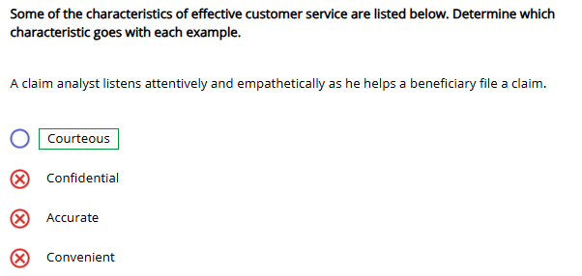
The insurer's branch offices are open late during the week for customer service transactions.
- Courteous
- Confidential
- Accurate
- Convenient
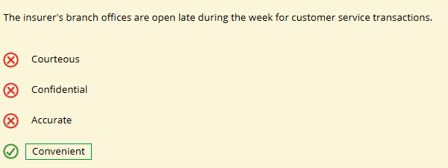
Financial professionals provide correct information to policyowners about the terms of their policies.
- Courteous
- Confidential
- Accurate
- Convenient
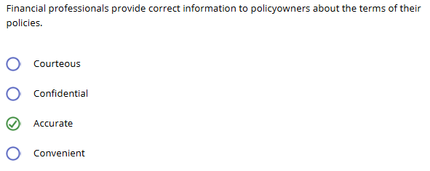
Before processing a policy change, CSRs verify that the person requesting the change is authorized to so.
- Courteous
- Confidential
- Accurate
- Convenient
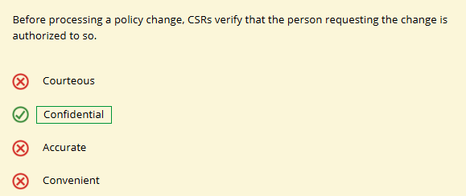\

Customer Service Interactions
Learning Objective
Describe the purpose of customer service, and describe some typical customer service transactions for individual life and annuity products.
Customer service is anything but boring. Customer service involves juggling activities to satisfy customers and fulfill contractual promises.
CSRs answer customers' questions, furnish information, and maintain records. In particular, customer service representatives (CSRs) perform the following activities:
- Process policy changes
- Administer financial transactions that relate to policies and policy values
- Engage in conserving, up-selling, and cross-selling in some companies
- Handle complaints
- Detect and prevent fraud
Let's look at each of these activities.
Processing Policy Changes
CSRs process policy changes over the phone, send the policyowner a form to complete, or direct the policyowner to a website for a self-service change. With all contact methods, the policyowner would supply the same information to the company.
Click or touch the PDF icon in the box below for a sample policy change form.

This policy change form shows the types of information companies typically need in order to process a policy change.
Administering Financial Transactions
Customers who contact an insurance company often need to complete financial transactions, such as these. (Click or touch in the boxes below to learn more.)

Fund Allocations
In a variable insurance or annuity product, the policyowner chooses how premiums will be invested; and he can change his investment fund choices periodically.

Policy Loan
A policyowner can request a policy loan, which is a loan that an insurer makes to a policyowner using the cash value of a policy.

Dividend Options
An owner of a participating policy can receive policy dividends in several ways, and he can change how he wishes to receive the dividends periodically.

Surrender
A policyowner can surrender—or terminate—her policy and receive the net cash surrender value—the actual cash value available to a policyowner upon policy surrender or lapse.

Reinstatement
After a life insurance policy has lapsed, the policyowner may ask to reinstate—or put back in force—the original policy.

Replacement
A replacement occurs when a policyowner surrenders his life policy or annuity and uses the money to replace it with another life policy or annuity.

More About Replacements
Because a replacement can potentially harm rather than help a policyowner, most jurisdictions have laws and regulations governing insurers and financial professionals when a replacement is involved.
For example, in some jurisdictions, the financial professional must provide the customer with a notice describing the effects of replacing a policy.
CSRs help carry out each replacement ethically, legally, and with full disclosure to the policyowner.

Replacements can be internal or external. Is surrendering an insurance policy and using the proceeds to buy another insurance policy from the same insurer an internal or external replacement?
- Internal
- External
- Need more information to determine

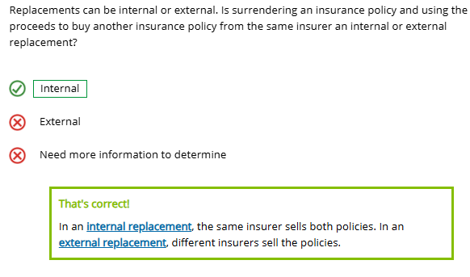
If not handled properly, a replacement could have serious tax consequences for the policyowner.
In the United States, if the Internal Revenue Service treats a replacement as a surrender, the policyowner has to pay federal income tax on the excess of the proceeds over the cost basis of the policy.
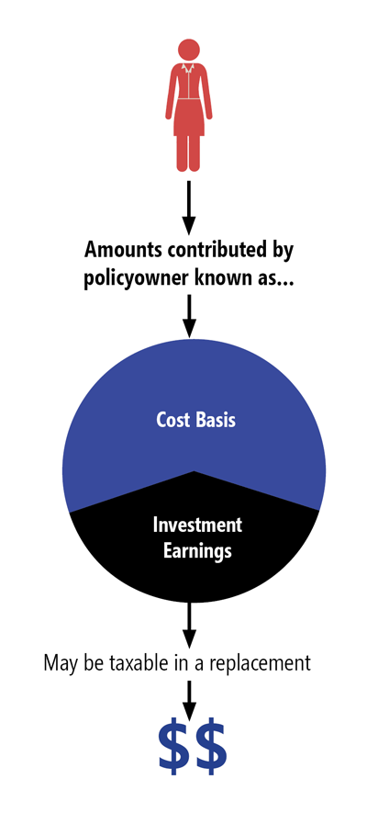
However, Section 1035 of the U.S. Internal Revenue Code permits the tax-free exchange of certain insurance and annuity policies. This tax-free exchange is known as a Section 1035 exchange.
Three exchanges qualify as 1035 exchanges and are not taxable events:
- One life insurance policy for another life insurance policy, where both policies insure the same person and have the same owner
- A life insurance policy for an annuity
- One annuity for another annuity where benefits are payable to the same person
Exchanges that do not qualify as 1035 exchanges are
- An annuity for a life policy
- A life policy insuring one life for a life policy insuring two lives

A policy replacement via a Section 1035 exchange is permissible for the exchange of (choose all that apply)
- A life insurance policy for an annuity
- An annuity for a life insurance policy
- A policy insuring one life for a policy insuring two lives
- One life insurance policy for another life insurance policy where both policies insure the same person and have the same owner
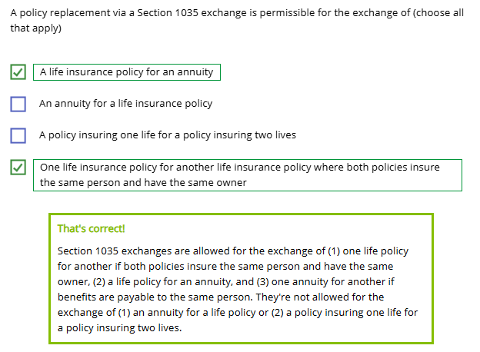
Conserving, Up-Selling, and Cross-Selling
CSRs may engage in conserving in-force policies and in up-selling or cross-selling.
Up-selling is promoting a more powerful, more enhanced, or more profitable product than the one a customer originally considers.
Cross-selling is identifying an existing customer's needs for additional products while selling, or after selling, a primary product and then promoting complementary products that, combined with the primary product, provide a more complete solution.

Determine whether the CSR's response is an example of conserving, up-selling, or cross-selling.

The policyowner wants to surrender his policy and use the policy's cash value for some other purpose than insurance. The CSR points out that the policyowner can get funds and continue the coverage by taking out a policy loan. If the policy is universal life, the CSR points out that the policyowner may withdraw part of the policy's cash value under the policy withdrawal feature.
- Conserving
- Up-selling
- Cross-selling
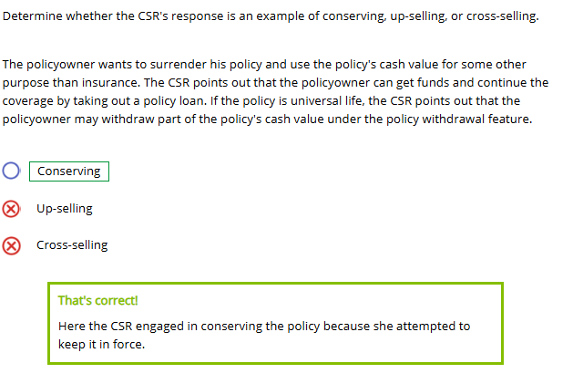
A life insurance applicant mentions to her financial professional that she is worried about her retirement savings lasting her lifetime. The financial professional asks if the applicant would be interested in hearing about longevity insurance and other types of products that can address that problem.
- Conserving
- Up-selling
- Cross-selling
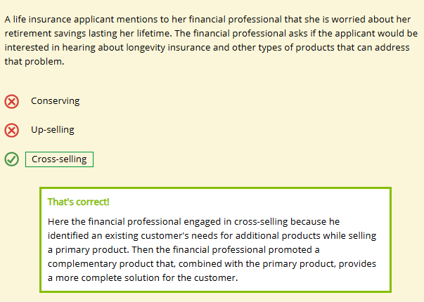
A universal life policyowner can't pay a due premium. The CSR tells him he can reduce the amount of future premium payments by reducing the policy's face amount. Or, the customer can avoid future payments but continue coverage by using the policy's net cash surrender value to buy either reduced paid-up insurance or extended term insurance.

- Conserving
- Up-selling
- Cross-selling
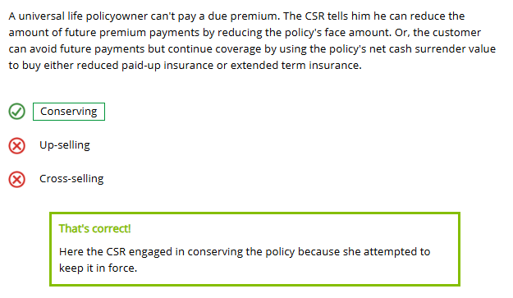
The policyowner wishes to renew a five-year term policy. The CSR explains some ways that a cash value policy might better meet the customer's needs.
- Conserving
- Up-selling
- Cross-selling
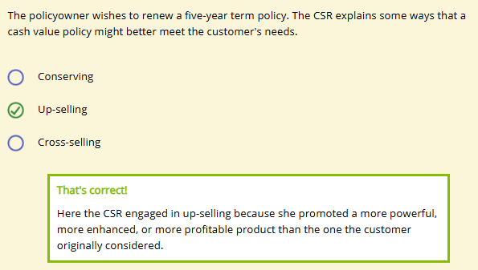
Handling Customer Complaints
No matter how well an insurer's customer service department functions, some customers are bound to complain. As this Expert describes, complaints are like every challenge: they provide an opportunity. In this case, an opportunity for a service recovery.

Don't fear customer complaints. They're a goldmine of information!
Companies study the source, number, frequency, and nature of complaints to detect customer service problems or trends. Customer complaints also offer a life insurance company insights into such issues as how customers understand the company's marketing messages and if, when, and how customers use the company's various products.
Most insurers have procedures for handling customer complaints. These procedures are designed to comply with regulatory requirements, minimize the risk of lawsuits, and improve customer service.
Complaint handling procedures vary by company and product. In some companies, for instance, the CSR who receives the complaint logs it into a complaint management system. A complaint management system consists of the processes and procedures for recording, evaluating, and taking action on complaints. Computer-based systems allow for quick recording and retrieval of detailed complaint information.
Most companies have a complaint team, also known as a problem resolution team, a work group dedicated to resolving customer complaints. A member of a complaint team may either attempt to resolve a complaint or forward the complaint to the appropriate area for handling.

When disbursing funds to a customer, Forthright Financial's employees must use acceptable communication channels and use specific methods of verifying customer identity in order to protect customers from possible fraud. Which of these approaches to safeguarding confidential information does NOT protect customers?
Insurance fraud can be committed by customers, insurance company employees, financial professionals, health care providers, or anyone else connected with an insurance transaction. Insurance fraud can be classified as either internal fraud or external fraud.
- Internal fraud is fraud committed by an insurer's employees, including its officers, directors, contracted employees, and financial professionals. Example: A contact center employee illegally accesses and copies a customer's account information, which he will use to fraudulently open a credit card in the customer's name.
- External fraud is fraud committed by people outside the company, including claimants and people who have a business relationship with the insurer. Example: A fraudster tricks a call center employee into thinking she's the genuine policyholder and takes out a loan against the policy.
Insurers today use technology to detect and prevent fraud. For example:
- Anti-fraud software aids in detecting and flagging potentially fraudulent activities.
- Predictive analytics allows insurers to analyze large amounts of data on past incidents of fraud to identify characteristics shared by known instances of fraud. Insurers then compare those factors with the data from a set of transactions currently under review to find fraud more easily.
- Insurers use their staff's experience, instincts, and common sense to spot potential fraud.
Common Types of Fraud
Common types of fraud CSRs may encounter include identity theft, senior financial exploitation, cybercrime, and account takeovers.
Identity Theft
Insurers are responsible for protecting the privacy of their customers' confidential information so that fraudsters can't engage in identity theft to access customer funds. To make sure that the people who contact the company really are who they claim to be, insurance companies may
- Require the customer to provide information, such as home address, telephone number, mother's maiden name, or password.
- Assign each customer a personal identification number (PIN) or customer identification number (CIN) that must be provided to proceed with a request. Using a PIN or CIN also protects against fraud that involves family members—although a family member may have access to a policyowner's personal information, they are less likely to know the policyowner's PIN.
- Use multifaceted authentication that requires a customer to use a PIN and supply a code the insurer sends to the customer's mobile phone number that's on record.
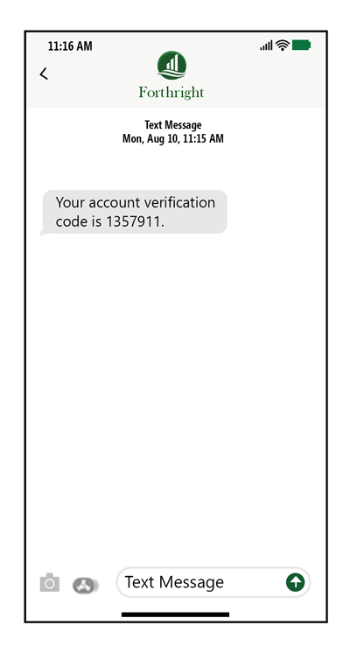
Senior Financial Exploitation
The most basic form of financial exploitation is the outright theft or misappropriation of income or assets by a family member, caregiver, friend, or other person. Most financial exploitation involves elderly individuals, who are vulnerable to identity theft, improper use of a power of attorney, and securities fraud.
Financial exploitation may be perpetrated by strangers, acquaintances, or trusted individuals, including
- Family members, including sons, daughters, grandchildren, and spouses
- Friends, acquaintances, or romantic partners
- Professional caregivers
- Health care providers
- Unscrupulous professionals or financial advisors
- Predatory individuals who target victims to engage in fraudulent activities or scams
Several states require insurance company employees to undergo training on identifying signs of financial exploitation, especially of seniors. With senior financial exploitation, some red flags that CSRs should be aware of include certain lifestyle changes. Employees should listen for these red flags during conversations with customers and report any questionable situations as they learn about them. Click or touch the right arrows below to see examples of red flags.

Red Flags for Senior Financial Exploitation
Cybercrime
Companies face a challenge keeping up with the tactics of criminals attempting to obtain electronic information. That's why most experts recommend that organizations make cybersecurity—which involves protecting a company's computer networks, systems, and data from unauthorized access—a priority.
Social Engineering and Phishing
Social engineering involves tricking people into revealing confidential information. For example, in a phishing attack, criminals posing as a trusted source contact a target and attempt to trick the person into revealing sensitive information, such as a username, password, credit card number, or Social Security number.
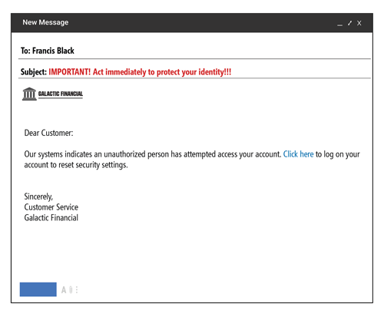
An organization's best defense against social engineering is to increase employee awareness.
Malware and Ransomware
Another threat is malware—malicious software installed on a computer or system by an unauthorized outside user in order to perform unwanted tasks, such as stealing data.
One type of malware is ransomware, which freezes a company's computers or blocks access to company data, restoring access only if the victim pays a ransom.
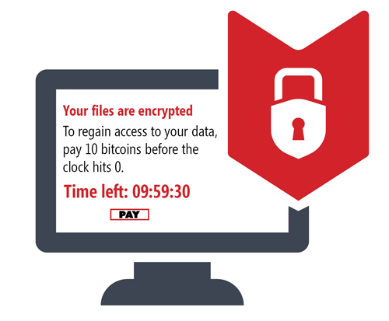
In a customer contact center, effective cybersecurity measures that CSRs can take to prevent data breaches include following the company's
- Cybersecurity best practices, including on how to recognize social engineering or malware attacks
- Customer verification requirements, such as multifaceted authentication
- Rules governing the handling of customers' personally identifiable information (PII)
Account Takeover Fraud
When a data breach does occur, cybercriminals can use the illegally obtained PII to commit account takeover (ATO) fraud. Customer contact centers may encounter cybercriminals who use stolen PII, which many life insurers use for customer verification, to gain access to customers' accounts. A cybercriminal who has a policyowner's PII can gain control of a policy and make changes, take out a loan against the policy, or even take a policy's entire cash value.
Using multifaceted authentication for all customer transactions can help CSRs detect attempted account takeovers.
Averting Account Takeover Fraud
A cybercriminal attempts to take over a Forthright customer's account.
The Forthright CSR sends an email or text to the customer that contains a real-time code.
In legitimate transactions, the customer supplies the code to the CSR. In fraudulent ones, the customer is alerted to the attempted account takeover.
Account takeover fraud is averted.

Insurers use a number of techniques to prevent and detect fraudulent acts. Which of these is a technology that allows insurers to spot potential fraud by analyzing large amounts of data on past incidents of fraud in comparison with the data from a set of transactions currently under review?
- Cybersecurity initiatives
- Predictive analytics
- Antifraud software
- Multifaceted authentication
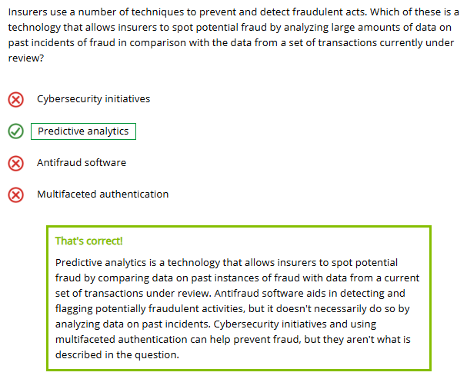
Data breaches occur when cybercriminals gain access to a company's information about its customers, including personally identifiable information (PII). Cybercriminals can use PII to engage in
- Account takeover fraud
- Phishing
- Securities fraud
- Social engineering
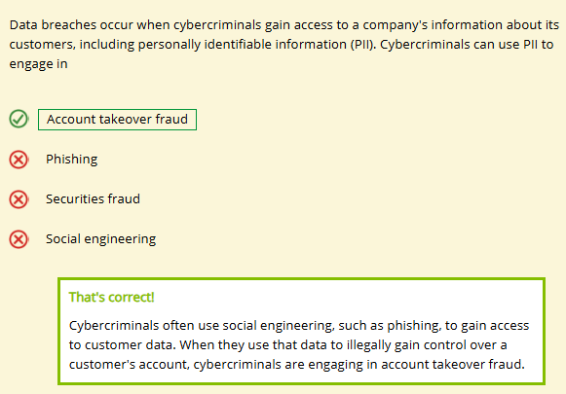

Why Is the Customer's Experience Important?
Learning Objective
Describe how managing customers' experiences benefits customers and companies.
Everyone knows that providing excellent service is important. But why?
\
Providing excellent customer service is important because it (choose all that apply)
- Increases productivity
- Results in cost savings
- Enhances a company's image and reputation
- Enables a company to attract and retain better employees and financial professionals
- Enables a company to gain a competitive edge
- Attracts new customers
- Builds customer loyalty
- Retains customers
- Results in greater profitability
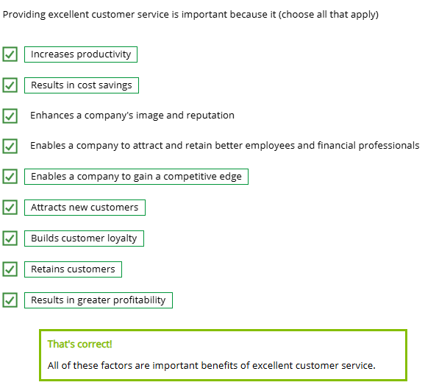
Providing excellent customer service is important because it (choose all that apply)
Customer Experience Management (CEM)
More and more in the twenty-first century, customer service is considered one part of the larger concept of customer experience.
Customer experience is the impression that a customer forms over time as the result of a series of encounters with the company. The customer experience is a product of the customer journey, which is the path each individual travels with the company, including every interaction across every touchpoint and every communication channel. An insurance customer's journey can last for many years and include many touchpoints, from the first time that the customer goes online to research insurance until, many years later, the customer or the customer's beneficiary receives the policy benefit or annuity contract value.
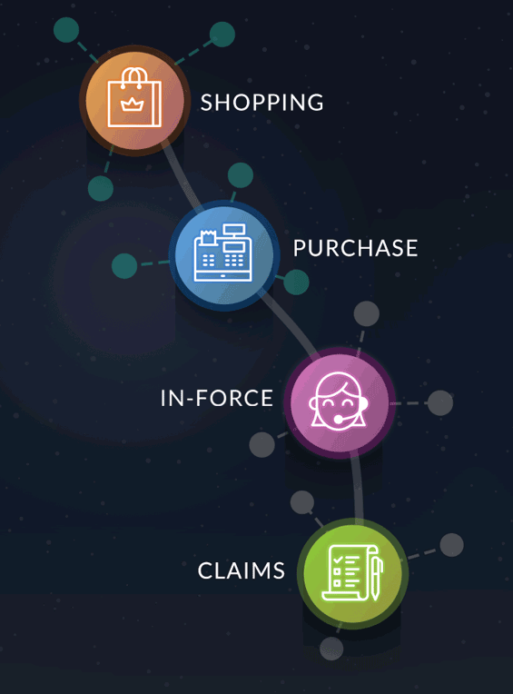
Most companies consider managing the customer experience to be a necessity to compete in today's business climate. Customer experience management (CEM) is a business strategy through which an organization manages all aspects of its interactions with current and potential customers. The strategy seeks to optimize the customer's interactions at every stage of the customer journey, including
- Shopping (recognizing a need, researching companies and products, comparing, getting a quote)
- Purchase (applying for and purchasing the policy)
- In-Force (maintaining, refining, and reviewing the policy)
- Claims (filing a claim, approval, payment)
Note that the customer service department is primarily involved at the in-force stage. Customer experience management involves more than the customer service department: it is an enterprise-wide initiative.
Customer experience management also seeks to optimize customer interactions across all communication channels through omnichannel service. To study customers' interactions with a company, insurers create customer journey maps depicting customers' typical touchpoints with the company and the possible communication channels through which customers might experience each touchpoint.
Companies also create customer personas, which are fictional representations of real-life customers belonging to different market segments with different needs and interests. For example, a retiree persona might prefer different communication channels than a Generation X persona or a Millennial persona. Companies can create different customer journey maps for different customer personas and use them to create personalized customer experience for each customer.
Voice of the Customer (VOC)
To create customer personas and journey maps, companies need to understand their customers. To do this, companies capture the voice of the customer (VOC) by gathering customer data. (Click or touch each box below to learn more.)

Active Voice of the Customer Data
Active VOC data is feedback that the company has solicited from customers, such as responses to survey questions regarding interactions with the company.

Passive Voice of the Customer Data
Passive VOC data is unsolicited customer behavior or feedback—information that customers reveal without being asked. For example, companies gather data about how customers behave when they visit the company website.

Companies also analyze customer calls to the contact center to gather VOC data. Customer service managers have traditionally listened to and analyzed customer service calls; many now also use speech analytics—software that analyzes not only the words and phrases that customers use, but also their tone of voice and voice changes that can provide information about their emotional states—as a source for collecting passive VOC data.
A longstanding customer service principle is that customer service is the responsibility of every employee at a company, not just "customer-facing" employees. Customer-facing employees interact directly with external customers; for non-customer-facing employees, their customers are internal customers. Employees need to provide high-quality service to their internal customers because that service eventually affects the experience of external customers. For example, what if an IT technician is slow in repairing a customer-facing employee's computer? Fewer customer-facing employees may be available to assist external customers, and customers will have to wait longer for service.
Customer Loyalty

From the customer's point of view, the benefit of CEM is receiving products and services that meet their needs. From the company's point of view, the goal is to maximize customer loyalty. Each successful touchpoint has the potential to increase a customer's loyalty. Among the many advantages to a company of customer loyalty are the following:
- New business through referrals and positive reviews in public forums
- A dependable revenue stream
- Opportunities for additional purchases
- Data that can be used to further improve the customer experience
In an insurance company today, the activities of the customer service department are typically part of an enterprise-wide strategy that is driven by data and technology. Given the numerous channels that customers can use to communicate with companies in the twenty-first century, customer service employees strive to provide a consistent, high-quality experience to all customers, no matter how they choose to interact with the company.
How Technology Affects Cx
Technology has become an important part of life for most people. For most companies, it is also an important way of doing business.
Seamless Processes
Insurers provide effective customer service and encourage customer loyalty by providing a seamless customer service process through a variety of service options. A seamless process is a smooth process designed so that a customer is not inconvenienced by—or even aware of—the steps involved in fulfilling the customer's request. Many automated systems, such as workflow systems and document management systems, are essential technologies that together allow an insurer to provide a seamless customer service process.
Personalized Customer Service
Technology also helps in providing personalized customer service through a variety of service options. Most insurers offer customers a choice of self-service, human-assisted service, or a combination of self-service and human-assisted service. Some people want customer service to be conveniently available anytime and anywhere, and technology lets insurers offer self-service options to meet this need.
Data Collection
Technology also allows insurance companies to gather useful VOC data about customers. Companies that don't collect and analyze data about their customers can only make assumptions about what their customers want and need. Companies that continually monitor the activities of their customers and their competitors are able to gain a deeper understanding of their customers' wants and needs, develop better ways to satisfy those needs, and improve the customer experience.
Artificial Intelligence (AI)

Insurance companies increasingly use artificial intelligence (AI) technology to provide self-service options while streamlining company operations. One type of AI commonly used is a chatbot. Chatbots are robotic CSRs or agents that can recognize and interpret human language and provide information. Customers communicating with a chatbot may be unaware that they are not talking to an actual person.

A customer's feeling of attachment to or preference for a company's people, products, or services is
- Service recovery
- Customer retention
- Customer loyalty
- Customer satisfaction
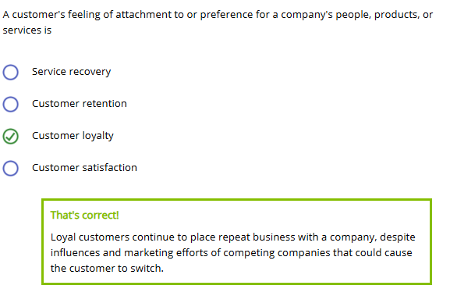
True or False?
Journey maps follow real customers.
- True
- False
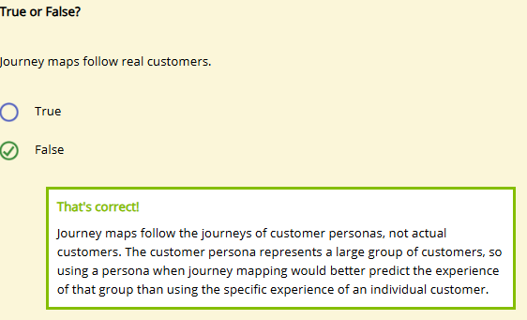
Indicate whether each of the following is an example of active or passive VOC data collection.
Collecting data about the frequency of complaints by using speech analytics software on a sampling of recorded customer phone calls
- Active
- Passive
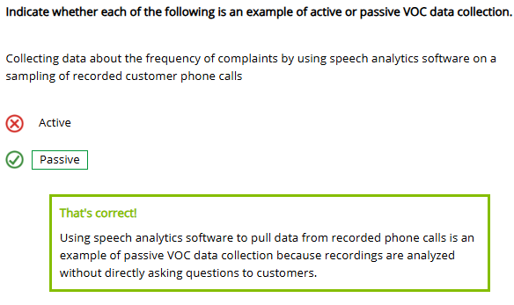
Having customers rate customer service after a call to the contact center
- Active
- Passive
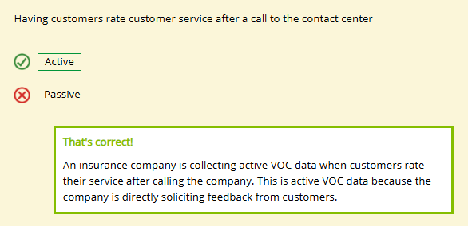

Customer Service Monitoring and Evaluation
Learning Objective
Describe how insurers monitor and evaluate their customer service.
In an insurance company, managers evaluate customer service by using qualitative and quantitative performance measurements. Performance measurement is process through which a company
- Decides what activities are key to the achievement of the company's goals and objectives
- Decides how to measure the performance of those activities
- Decides what performance standards it hopes to achieve
- Gathers the measurements
- Communicates the results

Which of these is an example of a qualitative performance measurement?
- The abandonment rate is below 5 percent.
- CSRs handle all telephone calls with courtesy and professionalism.
- CSRs respond to all written requests for beneficiary changes within two days of receipt.
- CSRs process 90 percent of all transaction requests within one week of receipt.
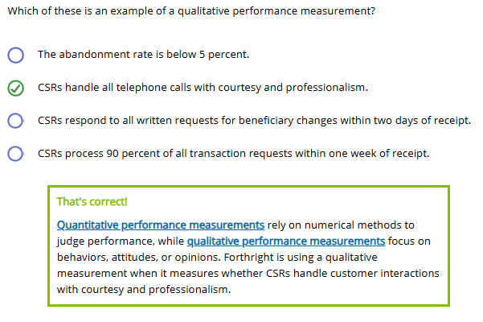
Qualitative Performance Measurements
Certain types of customer satisfaction surveys, monitoring, and mystery shopping are examples of qualitative customer service performance measurements. Click or touch each heading below to learn more.
Customer Satisfaction Surveys
A customer satisfaction survey helps a company determine whether its products, services, and prices are meeting customer expectations. A well-designed survey can also measure customer loyalty.
Some insurers send a short general survey to randomly selected customers. Other insurers conduct a short survey after each transaction. For example, a customer may be asked to complete an automated survey at the end of a telephone call. Customers may be asked to comment on an individual CSR's timeliness, accuracy, and professionalism. In addition, customers may be asked if the CSR made them feel welcome or valued during the interaction.
Qualitative survey questions are open-ended, such as "What was your reason for calling today?" Open-ended questions can reveal not only how customers feel about an interaction (or the company), but also why they feel that way.

Monitoring
Monitoring is a process used to review and evaluate the quality of customer service interactions either as they happen or after the fact. Managers may listen to live or recorded customer service calls between customers and CSRs to see what is happening.
Many companies monitor all of their contacts with customers—not just those involving telephones. Complaints, for example, provide qualitative data in the form of letters, emails, social media posts, and phone calls. Online data collection methods are especially useful for monitoring complaints.
Monitoring complaints that come from customers, employees, financial professionals, regulatory agencies, and consumer groups helps a company identify recurring service problems, service gaps, and process breakdowns. An insurer can use the information obtained from complaints to improve its processes and its communication with customers, with the goal of improving the customer experience.

Mystery Shoppers
Another way to gather qualitative information about CSRs' performance is through mystery shoppers. Mystery shoppers are either employees unknown to the CSR or independent contractors that conduct transactions as if they were real customers. At the end of the transaction, the mystery shopper records details about how the CSR managed—or failed to manage—the interaction on a standardized response form. The questions included in the form depend on the specific responses the company wants to evaluate.

Start
This CSR knows her procedures, and she handled the "customer's" request properly and thoroughly. She showed empathy to the mystery shopper, as well. Empathy is the ability to understand another person's emotional state and imagine how you would feel in a similar situation. That caring attitude creates satisfied and loyal customers.
Quantitative Performance Measurements
Insurance companies use quantitative performance measurements to evaluate aspects of customer service such as speed, accuracy, and timeliness. Other quantitative performance measures assess productivity, which is often an indication of how quickly and efficiently a process is working.
Quantitative performance measurements are useful because they generate concrete information about people and their behaviors that can be analyzed, summarized in the form of numbers, and easily communicated to others.
Example
The source, number, frequency, and nature of customer complaints help detect customer service problems or trends.
Forthright compares these quantitative measurements with established benchmarks to identify areas needing improvement.
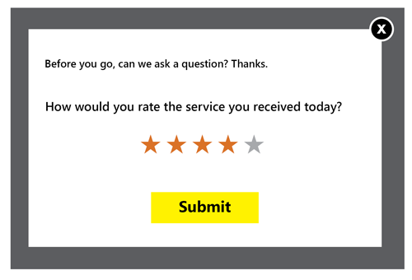
The most frequently used quantitative performance measurements are surveys. In surveys designed to gather quantitative data, a company asks a question—usually multiple choice—and it gets an answer in the form of a number, such as a service rating on a 5-point scale or a percentage of customers satisfied with how a CSR addressed their needs or concerns. Click or touch in the boxes below to learn more.

Quantitative Survey Question
On a scale of 1 to 5, with 1 representing poor service and 5 representing exceptional service, how would you rank the service received during this call?

Qualitative Survey Question
Based on the current call, how would you improve the service you received?

Many surveys have both types of questions because quantitative data provides numerical results that reveal what people think about a company, and the open-ended qualitative questions allow customers to give details about why they feel that way.

Beneficiary Melodia Jimenez recently called Forthright to file a life insurance claim. Below are questions on the survey she received from Forthright after the call. For each question, indicate whether the survey question is an example of a qualitative or quantitative performance measurement.
How satisfied are you with the service you received during your recent call with Forthright?
- Very satisfied
- Somewhat satisfied
- Neither satisfied nor dissatisfied
- Somewhat dissatisfied
- Very dissatisfied

- Qualitative
- Quantitative

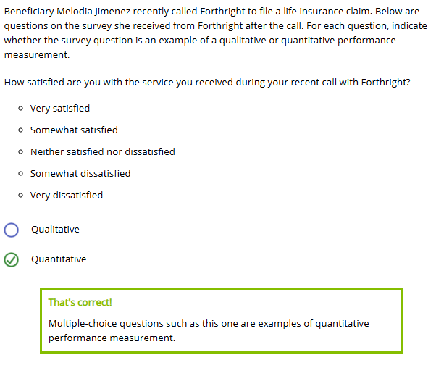
How could Forthright Financial improve your experience filing a claim?
Metrics
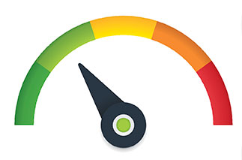

Which of the following are metrics that a company might use to measure success? Choose all that apply.
- Call turnaround time
- Customer retention rate
- Customer Satisfaction Score (CSAT)
- Error rate
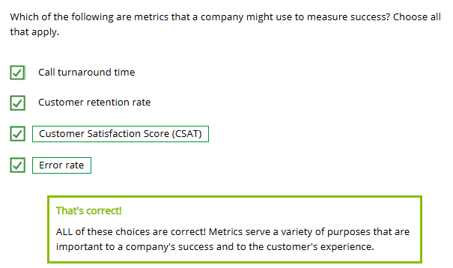
Successful insurance companies periodically evaluate their current processes and operations to identify ways they can improve and provide an exceptional customer experience.
A company's metrics are the quantitative performance measurements that it chooses to monitor to measure the success of its processes and key tasks. The types of metrics a company employs indicate the company's priorities as well as reflect on the company's performance.
Successfully implemented metrics
- Provide focus for the company, department, or employee
- Help company leaders make important decisions
- Identify ways to improve the performance of the company and its employees
Operational Metrics
Operational metrics measure the efficiency and effectiveness of company processes. Such metrics often help measure the success or failure of customer contact centers.
The operational metrics commonly used by insurance companies to measure customer service performance include accessibility, timeliness, accuracy, productivity, and quality. Click or touch each heading below to learn more.
Accessibility
One important customer service operational metric is accessibility—how easily customers can reach someone at the insurance company. Accessibility measures do not evaluate whether the customer's request was completed. They only measure whether someone answered the telephone or acknowledged an email and how long the customer waited for a response. Examples of accessibility measures include
- Service level. The percentage of inbound customer contacts the CSR answers within a specified time frame—for example, 90 percent within 20 seconds.
- Abandonment rate. The percentage of inbound telephone calls that are automatically placed on hold and then terminated by the caller before the call is answered by someone who can meet customer needs.
- Number of blocked calls. The number of inbound telephone calls that cannot get through to the customer contact center and instead encounter a busy signal or are transferred to voicemail or to a message to call back later.
- Average speed of answer. The average time in seconds to answer a telephone call or, depending on the context, the average time in seconds or minutes that telephone callers are on hold before being connected to someone who can meet customer needs.
- Misdirected calls. The number or percentage of inbound telephone callers who are transferred to the wrong department.

Timeliness

Timeliness (or turnaround time) is a general term for the time it takes to complete a customer-initiated request or transaction, such as answering a question, underwriting an application, processing a claim, issuing a check, or processing a withdrawal or an account transfer.
Insurance companies often use timeliness metrics as an indicator of how efficient their service providers are. Companies can gather additional information by measuring response time and first-contact resolution rates.

Productivity
Productivity is often an indication of how quickly and efficiently a process is working. Examples of productivity measures include processes completed, cost-per-call, and contacts-per-service provider.
Quality
The quality rate indicates the number of particular customer service transactions that result in no reported errors. The inverse of the quality rate is the error rate, which indicates the percentage of transactions that result in errors.
Both are often expressed as a percentage of the total number of transactions. For example, if 99 out of 100 transactions have no reported errors, the quality rate is 99 percent, while the error rate is 1 percent.

Service Metrics
Service metrics are measures of how happy customers are with the service a company provides.
Insurers use data to measure customers' satisfaction with the service they receive from the company. Common service metrics life insurance companies use to measure customer satisfaction are retention rates, Customer Satisfaction Score, and Net Promoter Score. Click or touch each heading below to learn more.
Retention Rates

An insurer can evaluate service quality in terms of the number of customers who are satisfied enough to remain with the company. Two commonly used measures of retention used by life insurance companies are the customer retention rate and the lapse rate.
The customer retention rate evaluates the amount of business that remains in force through a certain period of time. The inverse of the customer retention rate is the lapse rate, which indicates the percentage of business in force at the beginning of a certain time period that terminates during the period.

Customer Satisfaction Score (CSAT)
Customer Satisfaction Score (CSAT) is a measure of a customer's satisfaction with the services received from a company, expressed as a percentage. For example, CSAT may be the percentage of all customers who complete an after-call survey who say they were completely satisfied with the service they received. CSAT is measured using highly customized surveys designed to help insurers identify their specific strengths and weaknesses.
Net Promoter Score (NPS)
Net Promoter Score specifically measures customer loyalty. Net Promoter Score (NPS) asks customers to rank their likelihood of recommending a company or product on a scale of 1–10 and then subtracts the percentage of detractors (customers who ranked their likelihood of recommending as 0–6) from the percentage of promoters (customers who ranked their likelihood of recommending as 9 or 10).
Benchmarking
Using relevant metrics, insurers measure any improvements to or deterioration in service through benchmarking. Benchmarking is the process of
- Identifying the best outcomes that other companies have achieved for an activity or process
- Determining what practices produced those outcomes
- Implementing the best practices to equal or surpass the best outcomes
Benchmarking surveys are often conducted by independent third parties to give insurers an idea of what other companies' goals are and how successful they are at meeting those goals. In effect, benchmarking allows companies to improve service by implementing processes and procedures that have already been developed and shown to be effective.
Insurers choose specific operational and service metrics to serve as benchmarks. For example, if Forthright's CSRs have an error rate (an operational metric) of 3 percent, the company would compare its error rate to the average error rate for all life insurance companies. If the average error rate is only 1 percent, Forthright may set a benchmark of 1 percent for its error rate. Over time, Forthright would take steps to decrease the number of CSR errors, using the error rate metric to gauge progress toward the benchmark.

From January 1 to December 31, Forthright Financial had a customer retention rate of 90 percent. This means that the lapse rate was
- 10 percent
- 90 percent
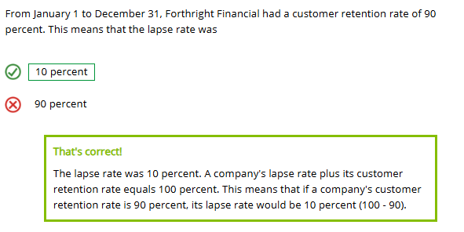
Determine whether each metric is an operational metric or service metric.
- Operational Metric
- Service Metric

Average speed of answer

- Operational Metric
- Service Metric
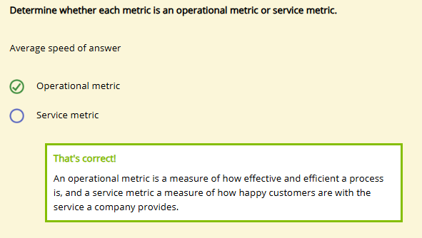
Accuracy
- Operational Metric
- Service Metric

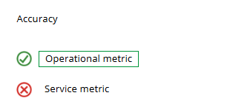
Net Promotor Score
- Operational Metric
- Service Metric
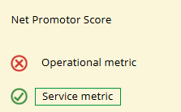
Quality rate
- Operational Metric
- Service Metric
